A periodic table is needed for this test.
1 Complete the table below:
Particle | Mass | Charge | Positions
Proton |  | +1
 | 1 |  | In nucleus
 |  | -1
(4)
2
a) Below are diagrams of four atoms.
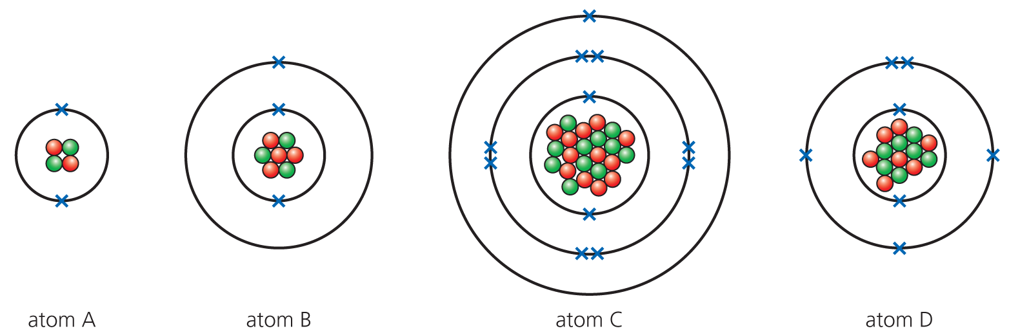
Using the periodic table, answer the following questions:
i) Which atom has the electronic configuration of 2,8,1? (1)

ii) Which of the above shows an atom of lithium? (1)

iii) Which element is Atom C? (1)

iv) What is the mass number of Atom D? (1)

b) Fill in the gaps below:
Isotopes have the same number of __________ but a different number of _______. (2)
c) Boron (atomic number 5) exists as two common isotopes: boron 10 and boron 11.
i) Complete the table below:
Isotope | Number of protons | Number of neutrons | Number of electrons | % abundance
Boron 10 | 5 |  |  | 20%
Boron 11 |  |  |  | 80%
(5)
ii) Find the relative atomic mass of boron and give your answer to 1 decimal place. Show your workings. (3)

d) The table below gives some information for several atoms and simple ions. Complete the table.
Atom/Ion | Number of protons | Electron structure
 | 8 | 2,6
Si
Cl⁻
 | 12 | 2,8
(6)
3 Sodium and potassium are both in Group 1 of the periodic table.
a) How many electrons do they both have in their outer shell? (1)

b) Why are they stored in oil? (2)

c) The Group 1 metals show a trend in their reactivity towards water. What is the reaction that occurs with water? (Equations would be helpful.) What is the trend in reactivity and why does this occur? (6)

4 Chlorine, bromine and iodine are Group 7 elements.
a) In terms of electronic structure, why are these elements placed in Group 7? (1)

b) Why is chlorine added to drinking water? (1)

c) The order of reactivity of the halogens can be found by displacement reactions. Complete the word equation: (2)
chlorine + potassium bromide → __________ _________ + _______________
5
a) Where in the periodic table are the transition metals? (1)

b) The transition metals have different properties from Group 1 metals. Place a tick in the box below to show if the property is from a Group 1 metal or a transition metal.
Property | Transition metal | Group 1
High melting point
Very soft
Compounds are white
High density
(4)
c) Argon is used to fill light bulbs. Why is this gas used for this purpose? (1)

6
a) Which of the following are mixtures and which are compounds? Place a tick in the correct box.
 | Compound | Mixture
Sea water
Sugar
Air
Common salt
(4)
b) The following are different methods of separating mixtures:
Filtration Distillation Fractional distillation Separating funnel Chromatography
Which method is the simplest method to separate:
i) Sand from water (1)

ii) Dyes in inks (1)

iii) Two immiscible liquids (1)

Total = 50

1
Particle | Mass | Charge | Positions
Proton | 1 | +1 | In nucleus
Neutron | 1 | 0 | In nucleus
Electron | 1/2000 | −1 | In shells
All 7 = 4 marks, 6-5 = 3 marks, 4-3 = 2 marks, 2-1 = 1 mark (4)
2
a)
i) C (1)
ii) B (1)
iii) Sodium (1)
iv) 14 (1)
b) protons; neutrons (2)
Isotope | Number of protons | Number of neutrons | Number of electrons | % abundance
Boron 10 | 5 | 5 | 5 | 20%
Boron 11 | 5 | 6 | 5 | 80%
i)

(5)
ii) (10 × ) + (11 × ) = 10.8 (3)
d)
Atom/Ion | Number of protons | Electron structure
O | 8 | 2,6
Si | 14 | 2,8,4
Cl⁻ | 17 | 2,8,8
Mg²⁺ | 12 | 2,8
(6)
3
a) 1 (1)
b) Reacts with the oxygen in the air. (2)

c)
Marks
6-5 | At least three different points well expressed
4-3 | A couple of points mentioned
2-1 | Not much detail

Points that can be made:
- Hydroxide solution formed.
- Hydrogen gas given off.
- Metal + water metal hydroxide + hydrogen
- 2M + 2H₂O 2MOH + H₂ – (Students deserve good credit for getting this one)
- Reactivity increases down group.
- Electron further away from nucleus (bigger atom) (OWTTE).
- More easily removed.
4
a) Seven electrons in outer shell (1)
b) Kills bacteria/micro-organisms. (1)
c) → potassium chloride + bromine (2)
5
a) In between Groups 2 and 3 / in middle (1)
b)
Property | Transition metal | Group 1
High melting point
Very soft
Compounds are white
High density
(4)
c) Inert/unreactive/full outer shell (1)

6
a)
 | Compound | Mixture
Sea water
Sugar
Air
Common salt
(4)
b)
i) Filtration (1)
ii) Chromatography (1)
iii) Separating funnel (1)
TOTAL = 50

